Introduced by the Council Member Corrigan:

ORDINANCE 2009-443
AN ORDINANCE AMENDING SECTIONS 656.399.19 (IDENTIFICATION OF CHARACTER AREAS) AND SECTION 656.399.25 (HISTORIC RESIDENTIAL CHARACTER AREA STANDARDS), SUBPART O (RIVERSIDE/AVONDALE ZONING OVERLAY), PART 3 (SCHEDULE OF DISTRICT REGULATIONS), CHAPTER 656 (ZONING CODE), ORDINANCE CODE, TO MODIFY THE MAP OF THE CHARACTER AREAS TO REVISE THE STOCKTON STREET CORRIDOR AND REVISE THE PARKING REGULATIONS IN THE HISTORIC RESIDENTIAL CHARACTER AREA; PROVIDING AN EFFECTIVE DATE.

BE IT ORDAINED by the Council of the City of Jacksonville:
Section 1. Section 656.399.19 (Identification of Character Areas) Amended. Section 656.399.19 (Identification of Character Areas) of Subpart O (Riverside/Avondale Zoning Overlay) of Part 3 (Schedule of District Regulations) of Chapter 656 (Zoning Code), Ordinance Code, is hereby amended to read as follows:
CHAPTER 656
ZONING CODE
* * *
PART 3
SCHEDULE OF DISTRICT REGULATIONS
* * *
SUBPART O
RIVERSIDE/AVONDALE ZONING OVERLAY
* * *
Sec. 656.399.19. Identification of Character Areas.
The predominant historic and existing use in the Zoning Overlay is single-family residential. Historic small-scale multi-family structures are mingled within the residential Zoning Overlay. Historic neighborhood-based commercial uses exist in Avondale, Park and King and 5 Points. Over time some larger historic residential structures were converted to non-residential uses. These changes, as well as demolition of large areas of historic structures, led to certain areas and corridors changing in character.
The Overlay defines these character area changes and these areas are expressed as Character Areas. These character areas include the Commercial, Office, Urban Transition, Industrial and Historic Residential Character Areas, and are defined in Table 1. below and includes the following map, which provides the boundaries for each character area.
* * *
Section 2. Figure 1.0 Character Area Map in Section 656.399.19 (Identification of Character Areas) of Subpart O (Riverside/Avondale Zoning Overlay) of Part 3 (Schedule of District Regulations) of Chapter 656 (Zoning Code), Ordinance Code, is hereby stricken and replaced with the Figure 1.0 Character Area Map provided below:

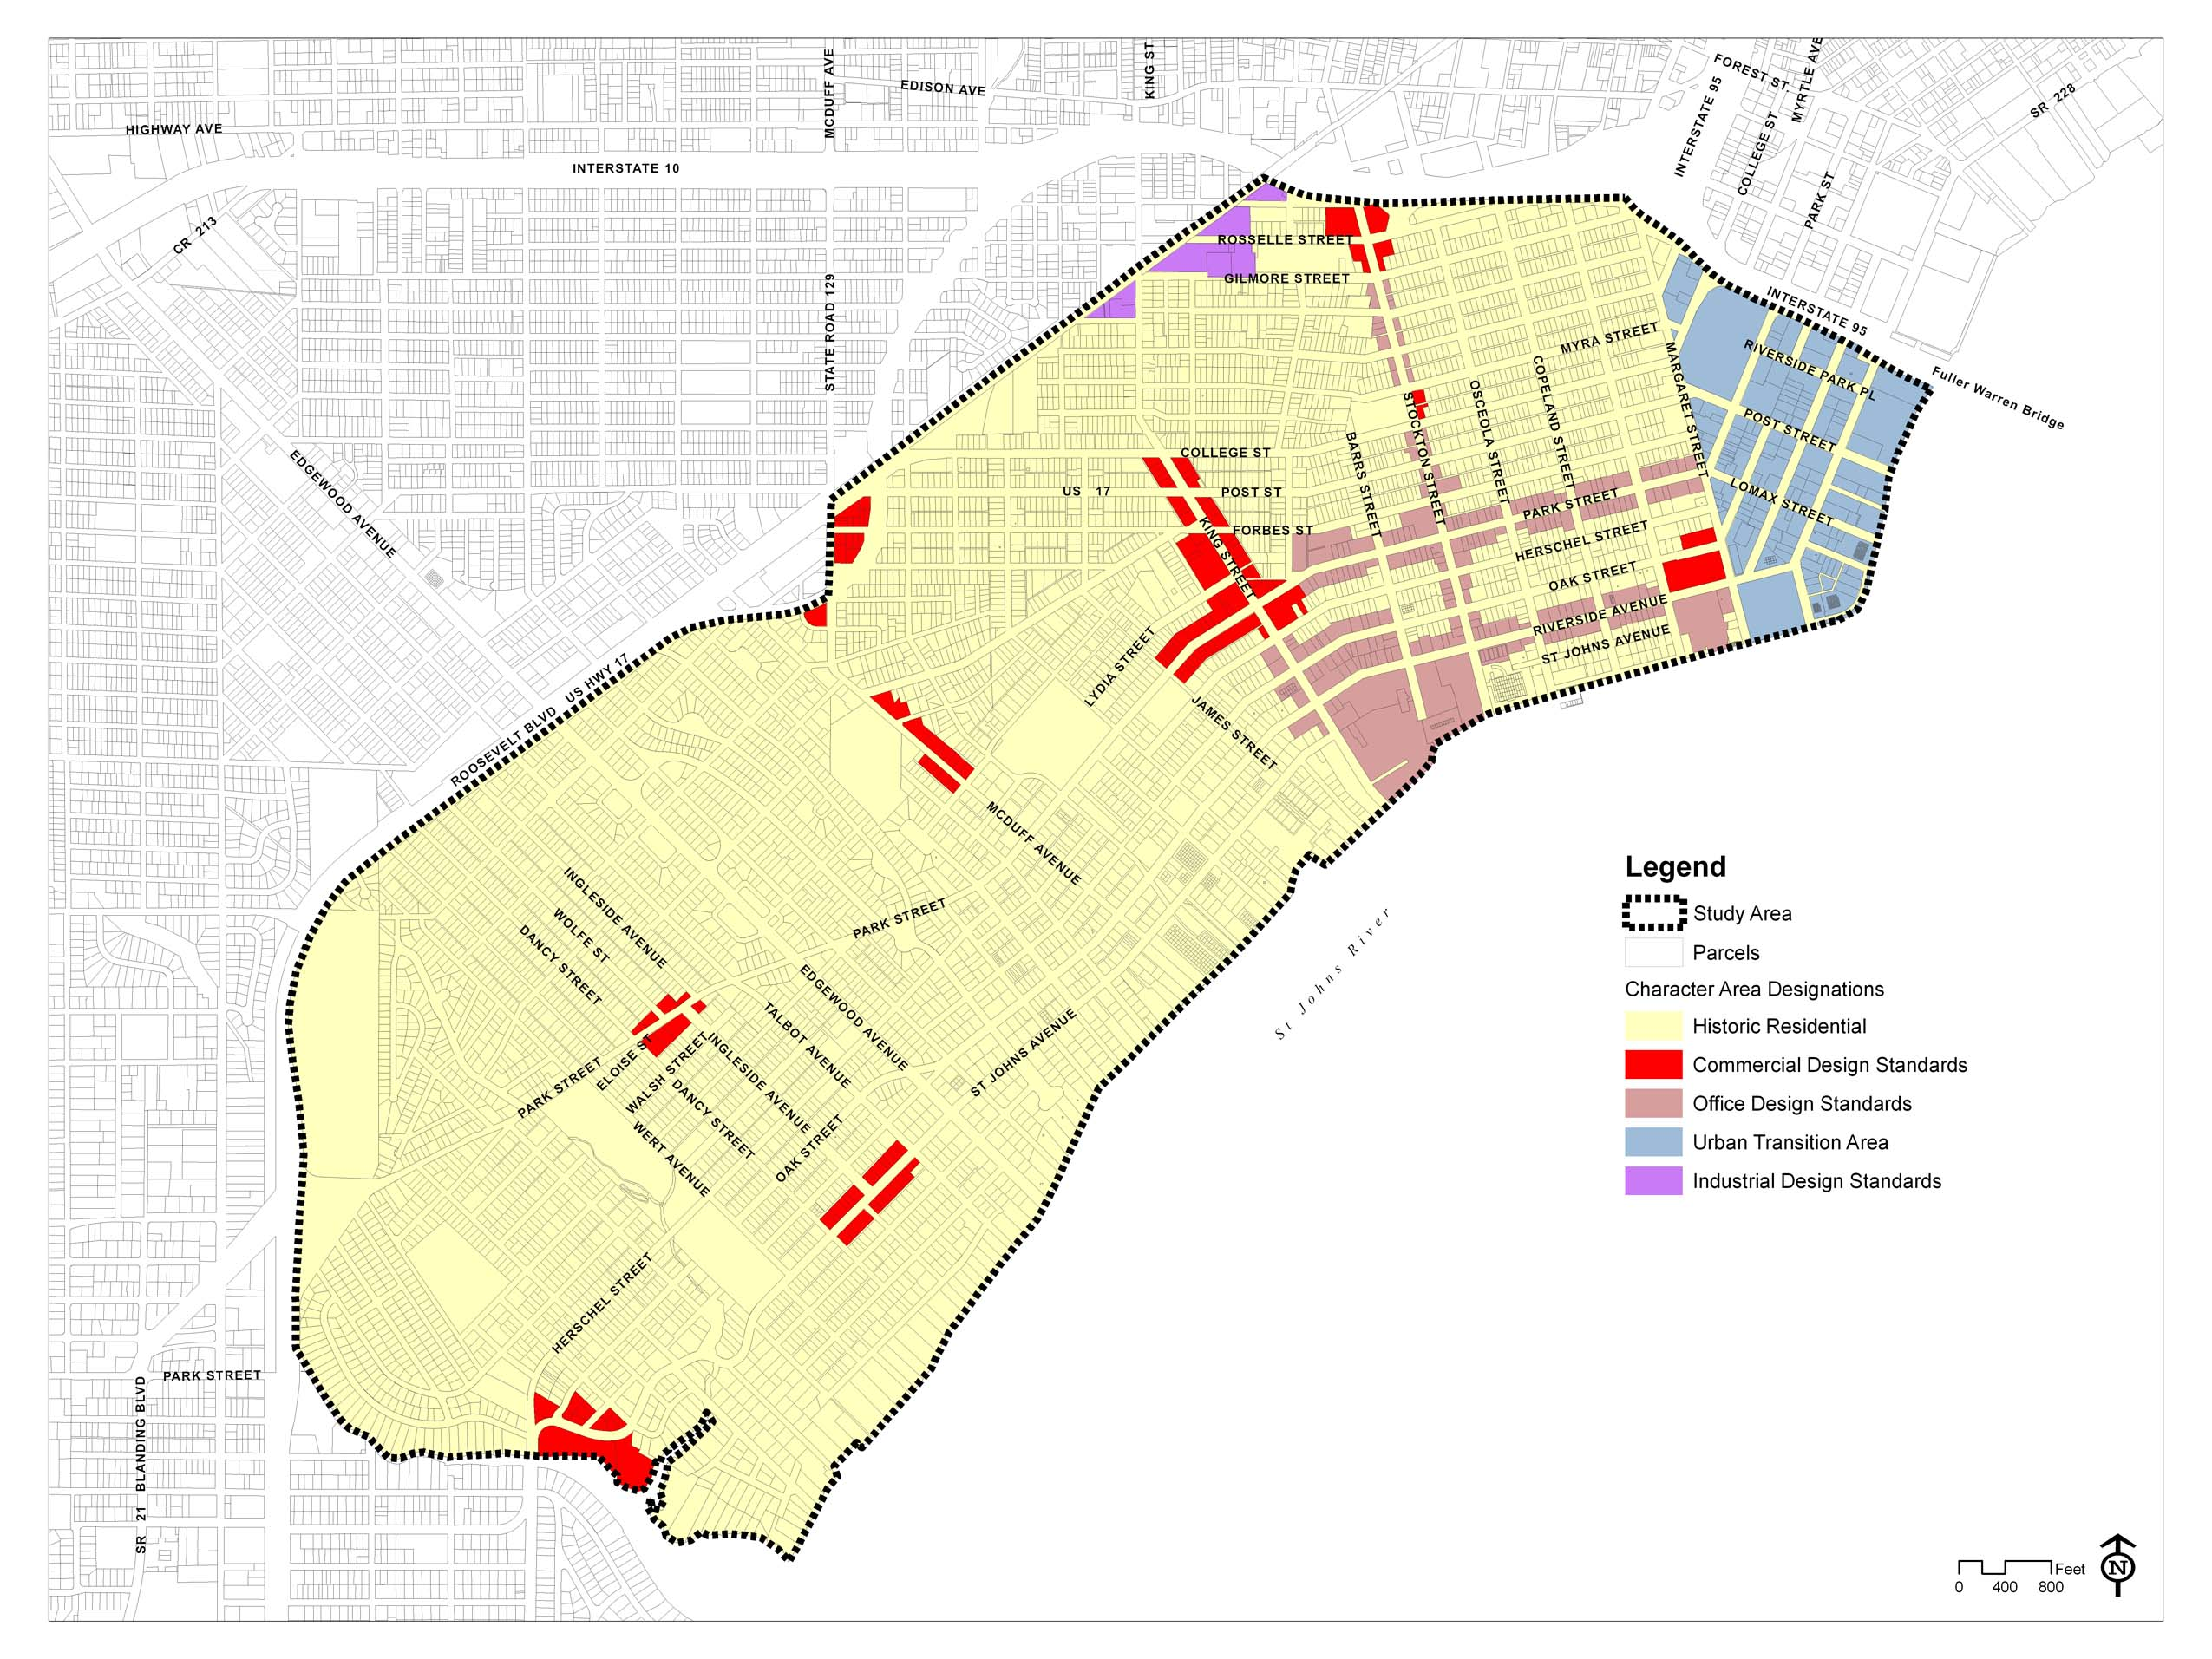
Figure 1. Character Area Map
Section 3. Section 656.399.25 (Parking Requirements) Amended. Section 656.399.25 (Parking Requirements) of Subpart O (Riverside/Avondale Zoning Overlay) of Part 3 (Schedule of District Regulations) of Chapter 656 (Zoning Code), Ordinance Code, is hereby amended to read as follows:
CHAPTER 656
ZONING CODE
* * *
PART 3
SCHEDULE OF DISTRICT REGULATIONS
* * *
SUBPART O
RIVERSIDE/AVONDALE ZONING OVERLAY
* * *

Sec. 656.399.25. Historic Residential Character Area Standards.
* * *
(2) Parking Requirements.
(a) There are no additional parking credits applied under Section 656.607(d) of the Zoning Code. Additionally, parking for conversions to office uses or new structures shall be provided on-site and no shared parking agreements will be considered for determining compliance with the parking requirements. All on-site parking for office, single-family and duplex or quadplex multi-family uses shall be stabilized and of a pervious nature, except for the driveway and required ADA accessible spaces. Conversions of contributing structures with an non-residential original use to residential uses may provide 50 percent of the required number of parking spaces set forth in Section 656.604(a).
* * *

Section 4. Effective Date. This Ordinance shall become effective upon signature by the Mayor or upon becoming effective without the Mayor’s signature.

Form Approved:

/s/ Dylan T. Reingold______________
Office of General Counsel
Legislation Prepared By: Dylan T. Reingold
/tmp/in/input.doc

